Common Infection Prevention Mistakes in the Linen Room

When staffing changes occur in the Linen Department, it’s common for Infection Prevention and safety training to be a low priority. Here is a list of commonly seen compliance violations to watch for when inspecting on-site linen rooms.

- Cardboard – No porous materials, they can harbor contaminants.
- Uncovered Linen (soil or clean).
- Carts in Hallways.
- Fire Code does not allow linen/pillows or any items closer than 18” to the ceiling on shelves/carts or storage rooms.
- Backup linen must be rotated.
- Personal items in linen carts or stored on shelves.
- Linen touching the floor.
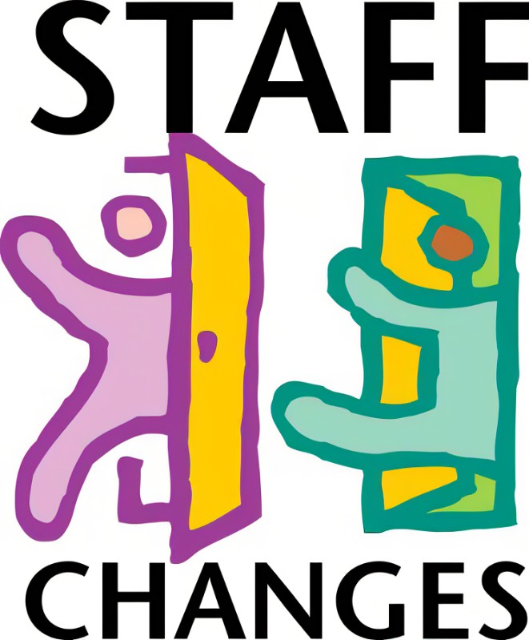
- Cross contamination with soil & clean in the same hallway/docks.
- Staff not wearing PPE when handling soiled linen and then delivering clean.
- Staff not washing hands after handling soiled linen.
- No food or food storage in linen rooms.

